**SMART SPENDING SYSTEM**

**(SSS)**

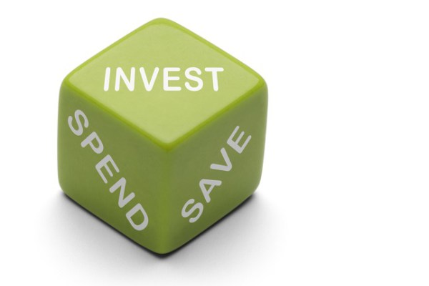

***Team 12- Vision Quest***

* Avinash Banala - 5
* Sai Smaran Chinthala – 11
* Rahul Nagavalli - 28
* Swetcha Reddy Vangala – 41

1. ***INTRODUCTION***

|  |
| --- |
|  |
|  |
|  |
|  |
|  |
|  |
|  |
|  |

**‘SAVE SMART SPEND WISE’**

Earn a lot, spend some, and save at least a little. We need a sophisticated life, not a luxurious one. Life gets very hard to lead if we are indebted to someone. Prevention is better than cure for health, likewise savings are better than debts for wealth. It is very easy **to** spend, but difficult to earn. However, we have to spend but in a way that we can readily have money for any unexpected problem. Have your control on money, don’t let money control you. So, spend wisely.

This is our motivation to develop the application ‘SMART SPENDING SYSTEM’. Most of the people in today’s generation are just not keeping a control on their money and the result of this is that they end up in the middle of ocean of debt. The main aim of our application is that it has to aid people to spend their money in most economical way, by not going to debts, still if any, to clear in an easy way. People should be in a position to spend money in cases of emergency. They should be able to spend their money for each and every need, be it a small one or any huge need.

1. ***PROJECT GOAL AND OBJECTIVES***

***GOAL:***

To develop an application that helps people to keep a track on their income, expenditure and savings.

***OBJECTIVES:***

* The main aim of this project is to keep a virtual track on the money being spent by adding past, future or recurring transactions and categorizing them.
* To give a platform for money which should be given to others by splitting it into equal portions.
* It can be used to alert the user when he exceeds his pre-planned monthly limit or if his present month’s expenditure exceeds that of his previous month.

***SYSTEM FEATURES:***

* Detailed info graphics.
* Friendly email remainders to others.
* Easily accessible notifications.

***SIGNIFICANCE:***

Like Fitbit tracks your health, this application tracks your expenditure, helps you plan your budget. A country needs a budget plan, similarly even our income also can be used effectively if we have a budget plan. This application is an aid for our budget plan.

1. ***PROJECT PLAN***

***ZENHUB***

**ISSUES**

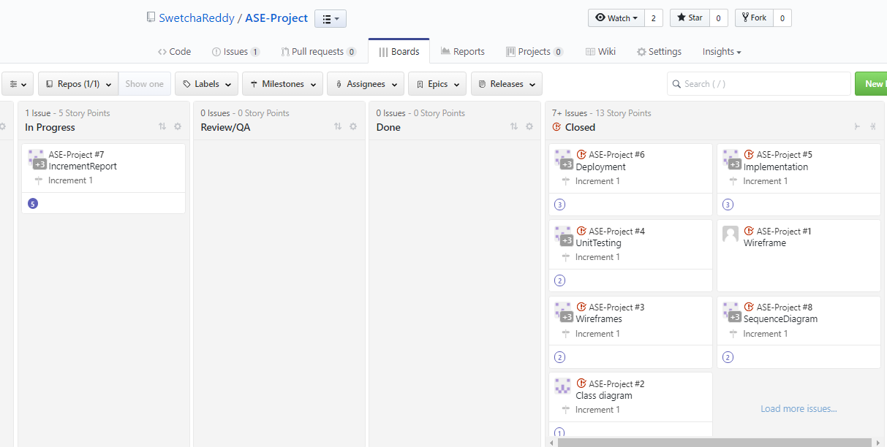

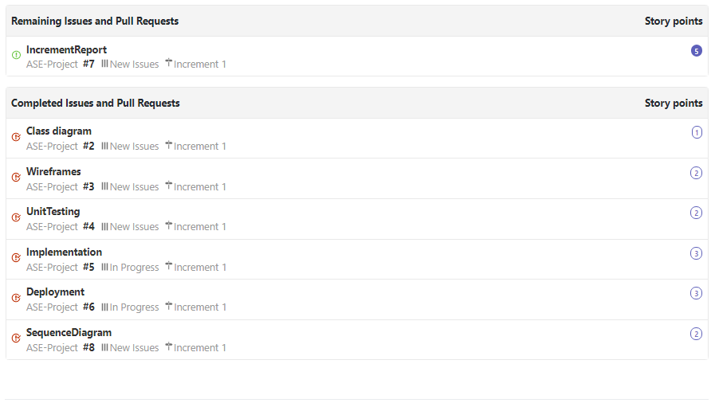

**CLOSED ISSUES**

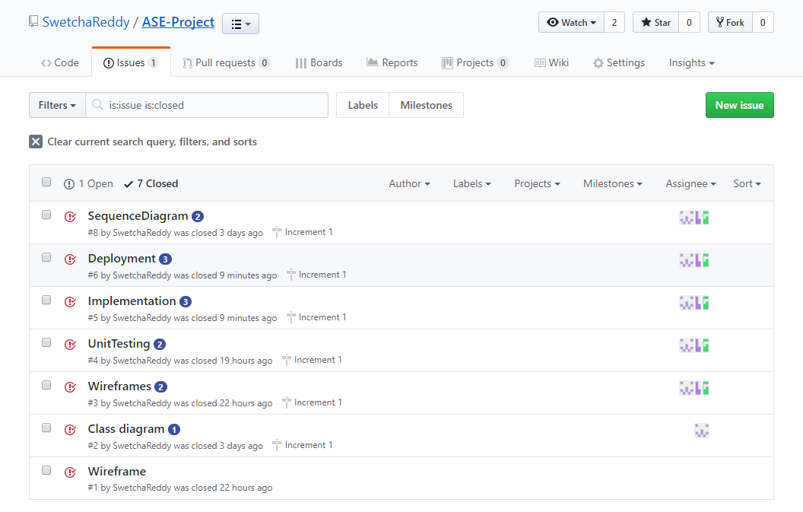

**BURNDOWN CHART**

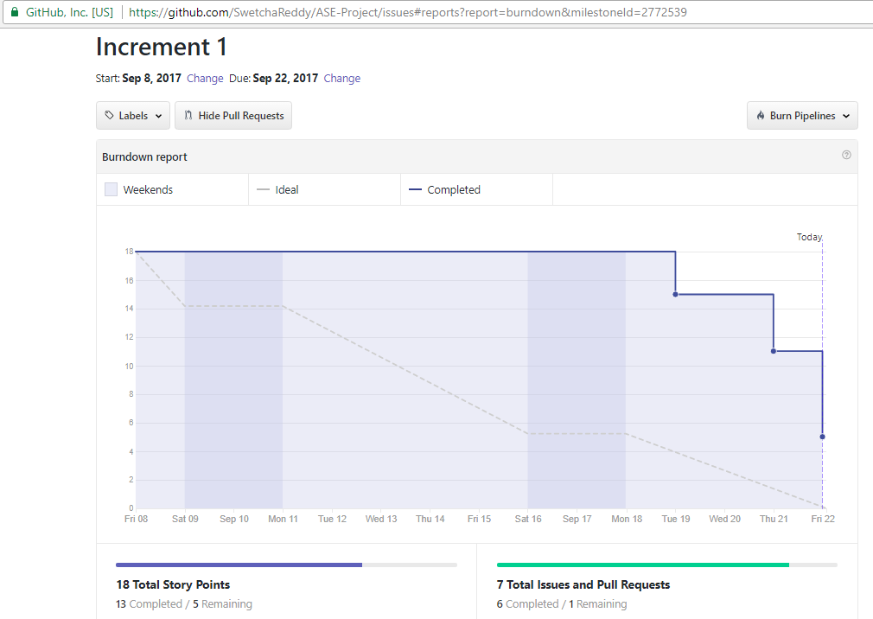

**TEAM MEMBERS**

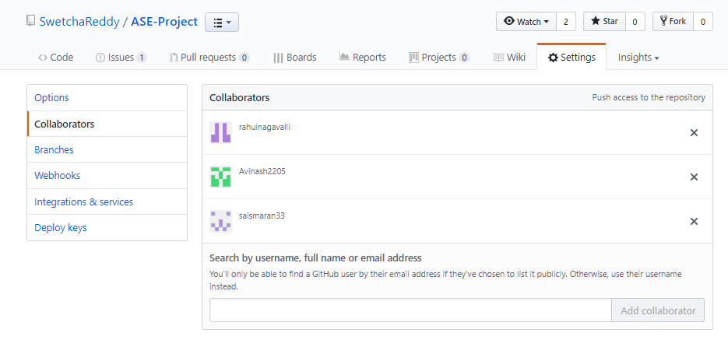

1. ***FIRST INCREMENT REPORT***

***REST APIs USED***

* **PLAID API**

Plaid is a REST API for banking data that provides access to high-quality transactional and account data for the major US financial institutions. Transactions are returned with a clean merchant name, categories, street address, geo co-ordinates, and more.

[Plaid](https://plaid.com/) is a REST API that is built for US-based banking authentication, verification, and data retrieval.

Add users with Plaid Link’s credential-based flow and post Income requests to the Plaid API. Once a user has been added, the account holder’s income information can be retrieved at any time.

* **YODLEE API**

Yodlee Aggregation API is designed for clients who need permission-based access and bank-level security to access their customers bank, credit card, investments, loan accounts and other financial data.  
Yodlee platform aggregates consumers financial data based on a user-permission model, whereby a consumer voluntarily provides online access credentials for an account or a set of accounts. The data is gathered and stored in Yodlee's database in a well-defined and normalized structure. The aggregation APIs allows you to retrieve and view this data.

***DESIGN***

***WIREFRAMES***

**LOGIN PAGE**

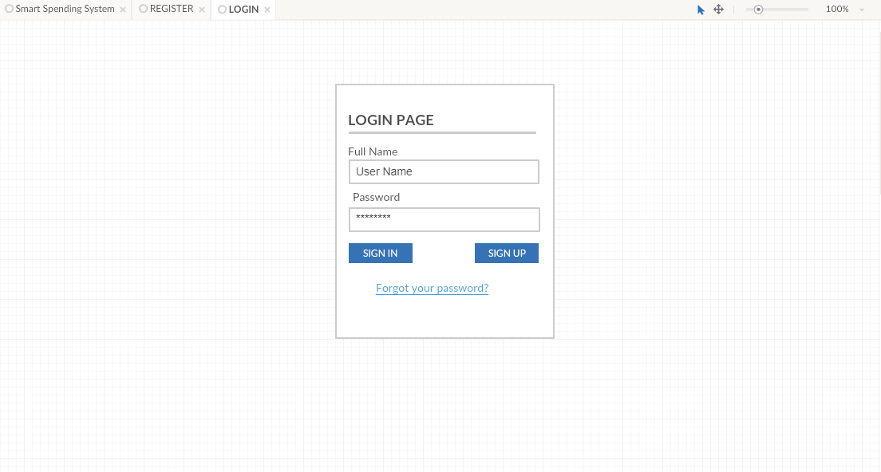

**REGISTER PAGE**

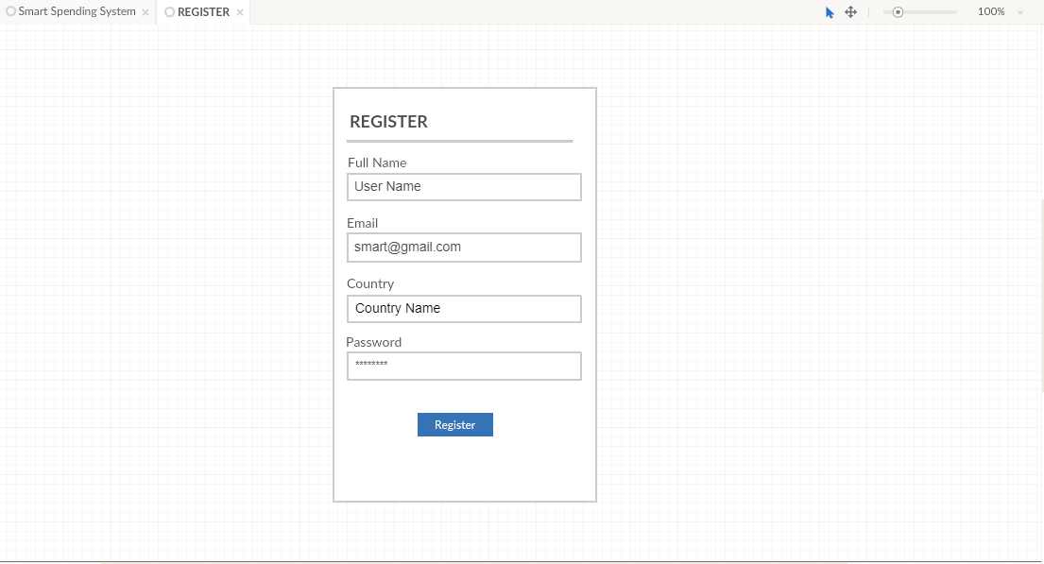

**APPLICATION PAGE**

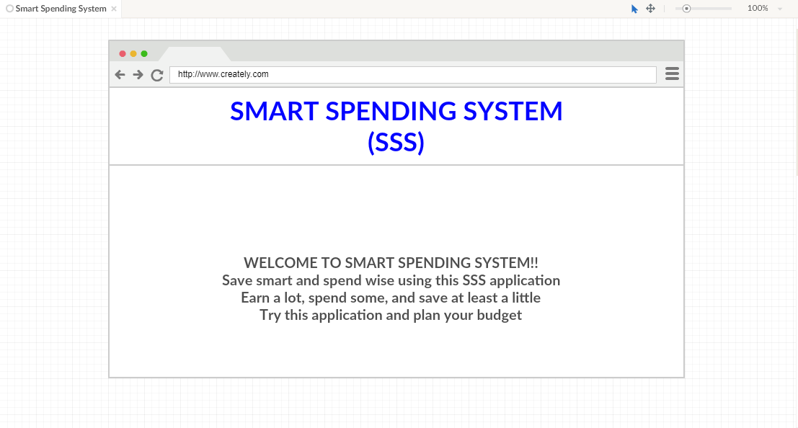

***ARCHITECTURE DIAGRAM***

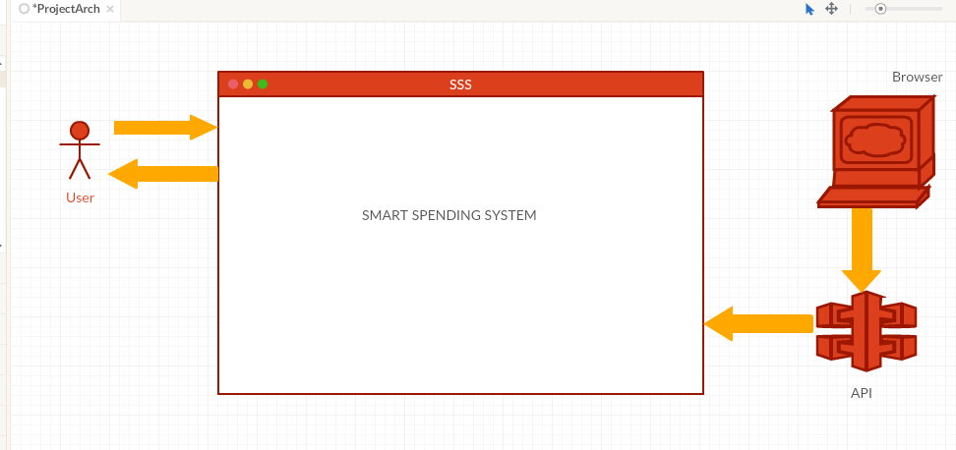

***CLASS DIAGRAM***

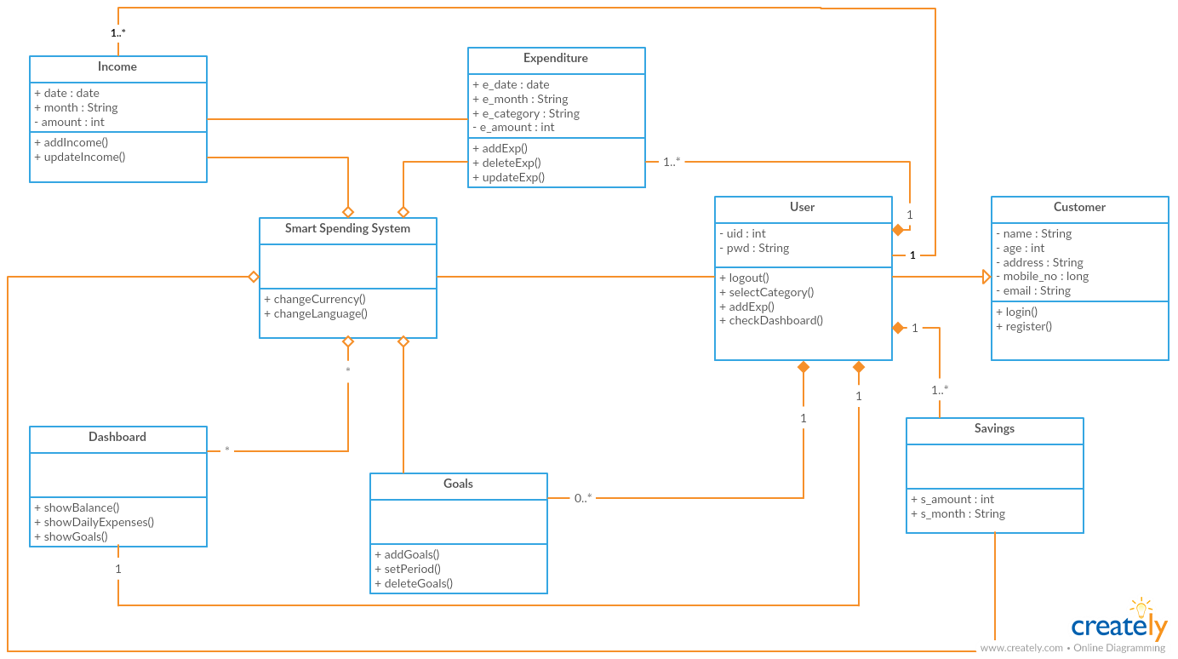

***SEQUENCE DIAGRAM***

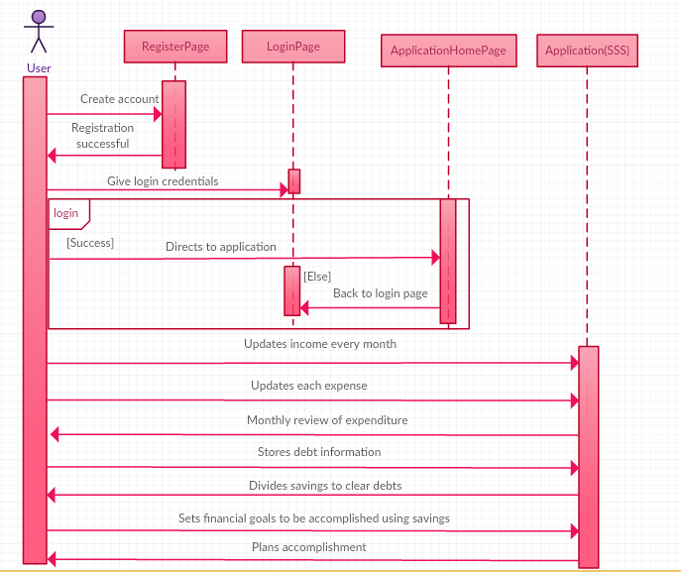

***USER STORIES***

* As a user, I want to register with the web application, so that I can start using the Smart Spending System.
* As a user, I want to login to the application, so that I can access my account.
* As a user, I want to keep a track on my savings, so that I can achieve my goals.
* As a user, I want to keep a track on my savings, so that I can clear my debt.
* As a user, I want to review my monthly expenditure, so that I can plan my budget better for the next month.

***USE CASE DIAGRAM***

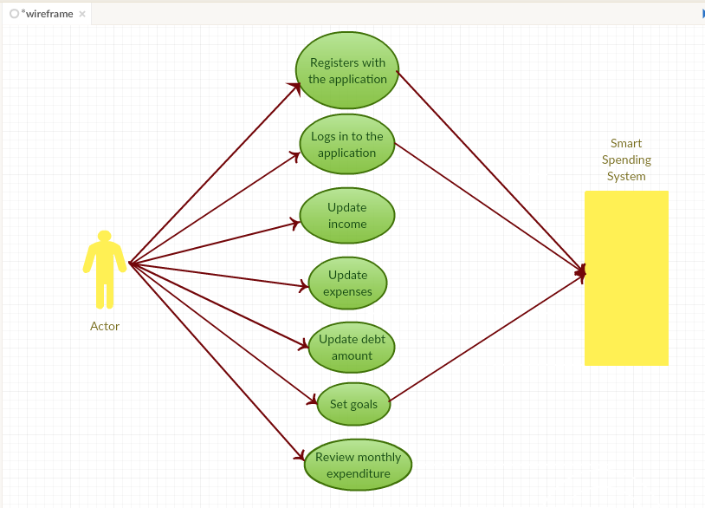

***TESTING***

|  |  |  |  |  |
| --- | --- | --- | --- | --- |
| **Test Case no.** | **Test Case** | **Description** | **Expected**  **Output** | **Result** |
| 1. | Successful  User Authentication | The user should login with username and password. | Successful Login | Pass |
| 2. | Unsuccessful  User  Authentication | The user logs in with wrong username or password | Login unsuccessful with error-Invalid username or password | Pass |
| 3. | Registration by new user | Admin accepts registration details from the user | Successful registration and transition to Login page | Pass |

***IMPLEMENTATION***

**LOGIN PAGE**

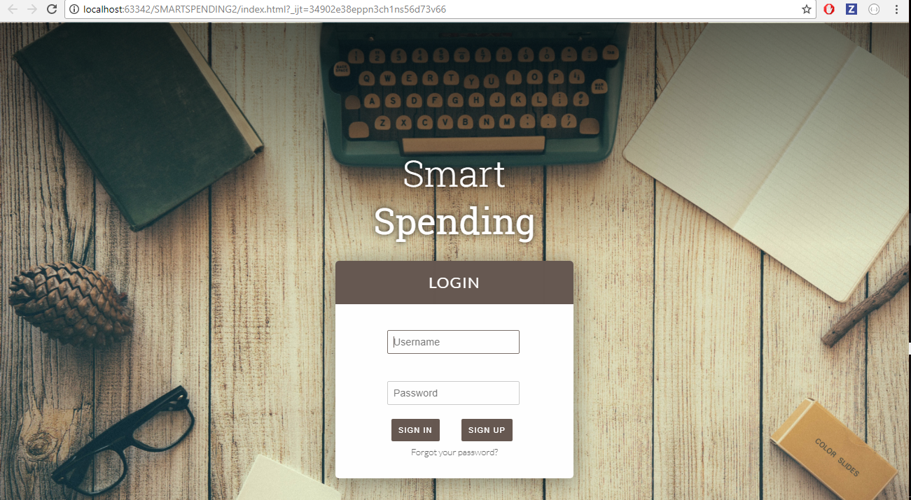

**REGISTER PAGE**

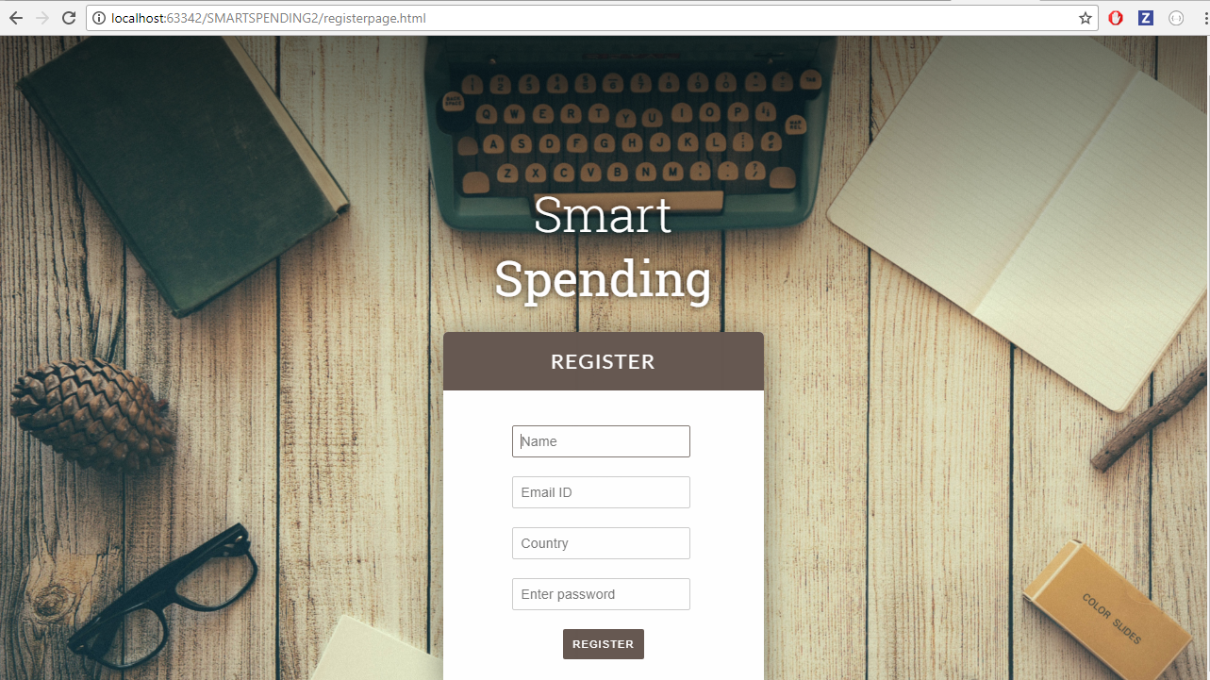

**APPLICATION HOME PAGE**

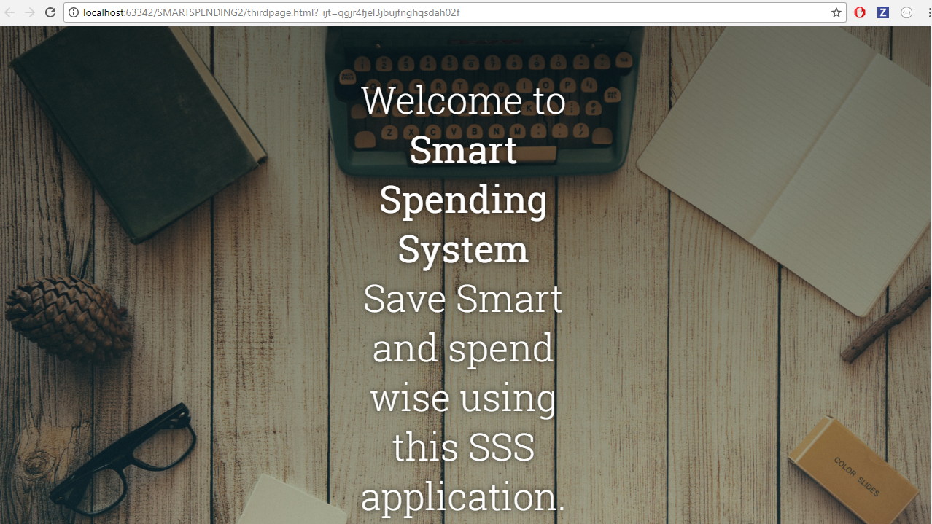

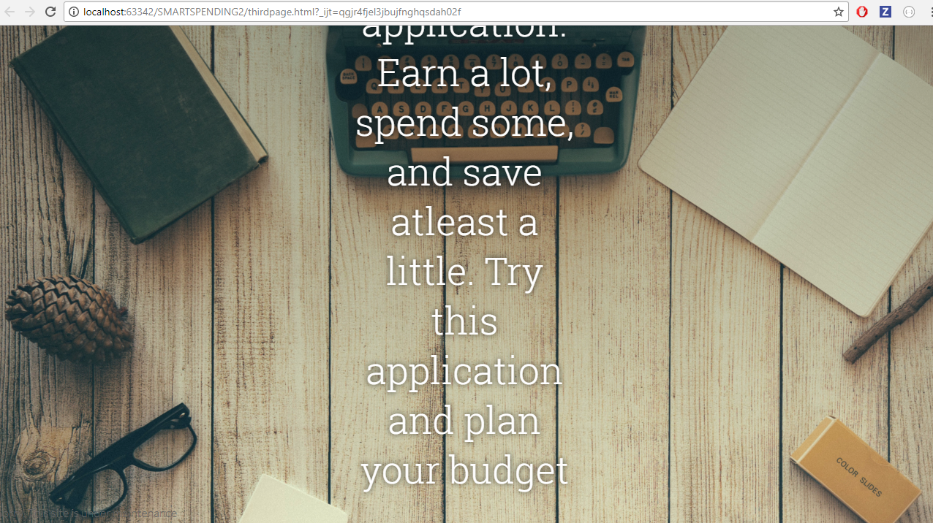

This is just a basic transition to pages. Final home page of the application is yet to be designed.

***PROJECT MANAGEMENT***

**STATUS REPORT**

***Work completed***

**Description**

* Created issues for Project Increment 1 in GitHub.
* Created wireframes.
* Created Class Diagram, Sequence Diagram and Architecture Diagram.
* Designed Login, Register and basic Application home pages.
* Implementation of the pages of the application.

**Responsibility**

**Task Person**

* Ground work for project All four in the team
* Issues Swetcha Reddy Vangala
* Wireframes Avinash Banala
* Class diagram Sai Smaran Chintala, Swetcha Reddy Vangala, Rahul Nagavalli
* Sequence Diagram Swetcha Reddy Vangala
* Application pages design Avinash Banala, Rahul Nagavalli, Sai Smaran Chinthala
* Testing Sai Smaran Chinthala, Rahul Nagavalli, Avinash Banala
* Documentation Swetcha Reddy Vangala

**Time taken =** 72 hours

**Contribution**

Swetcha Reddy Vangala – 25%

Avinash Banala – 25%

Sai Smaran Chinthala – 25%

Rahul Nagavalli – 25%

***Work to be completed***

**Description**

* Deisgn of application home page.
* Actual usage and APIs.
* Development of application.
* Proper navigation through pages.

**Responsibility**

We are going to work collectively as a team to develop our application.

**Time to be taken** = 30 day

**Issues/Concerns** – No issues.

**Bibliography**

[https://www.forbes.com/sites/samanthasharf/2016/03/02/12-free-apps-to-track-your-spending-and-how- to-pick-the-best-one-for-you/#3028b07d5445](https://www.forbes.com/sites/samanthasharf/2016/03/02/12-free-apps-to-track-your-spending-and-how-%20%20to-pick-the-best-one-for-you/#3028b07d5445)

<https://www.pennyapp.io/faq.html>

<https://plaid.com/docs/api>

<https://developer.yodlee.com/>

<https://dcrazed.com/free-css3-sign-up-registration-forms/>